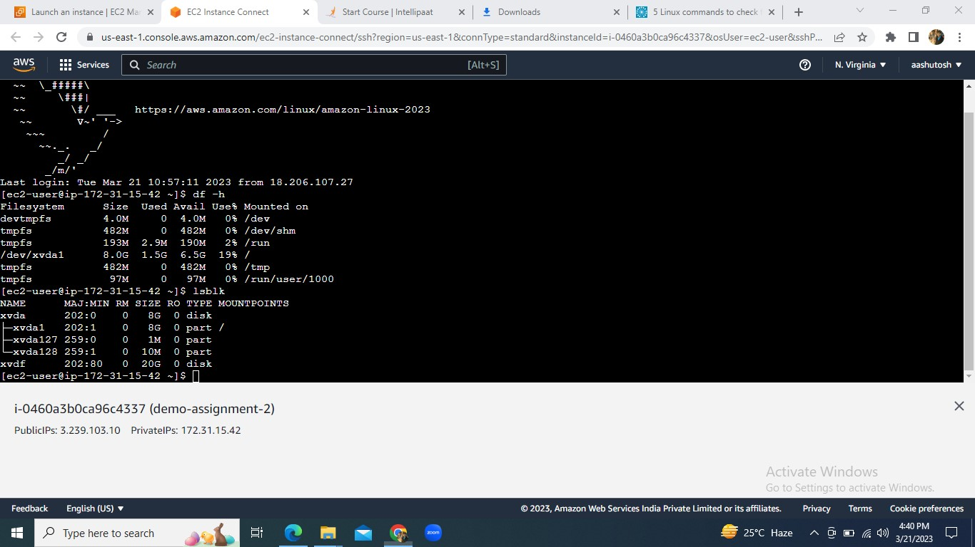

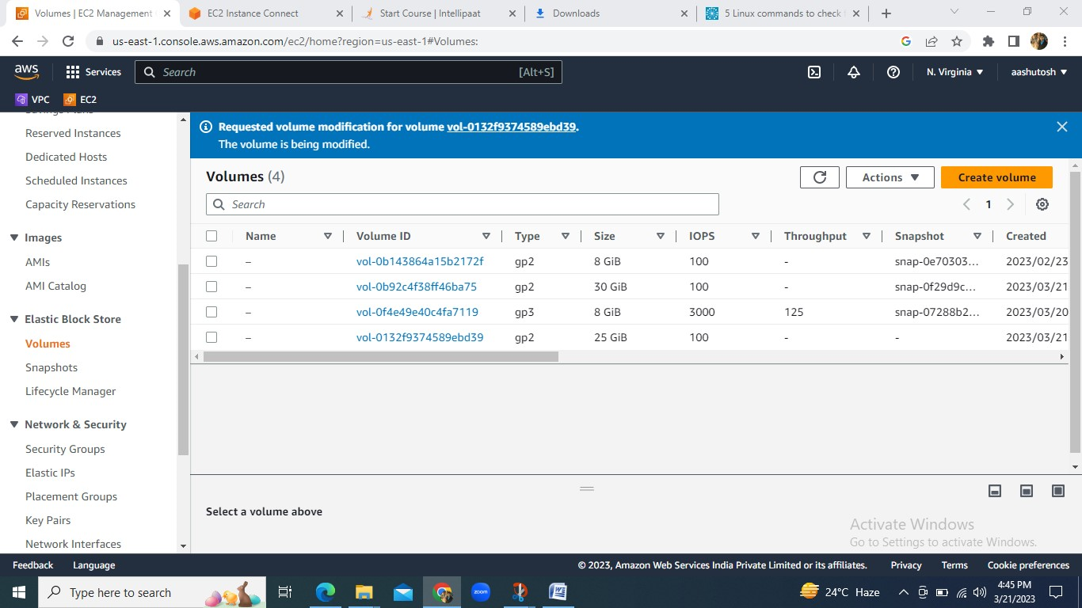

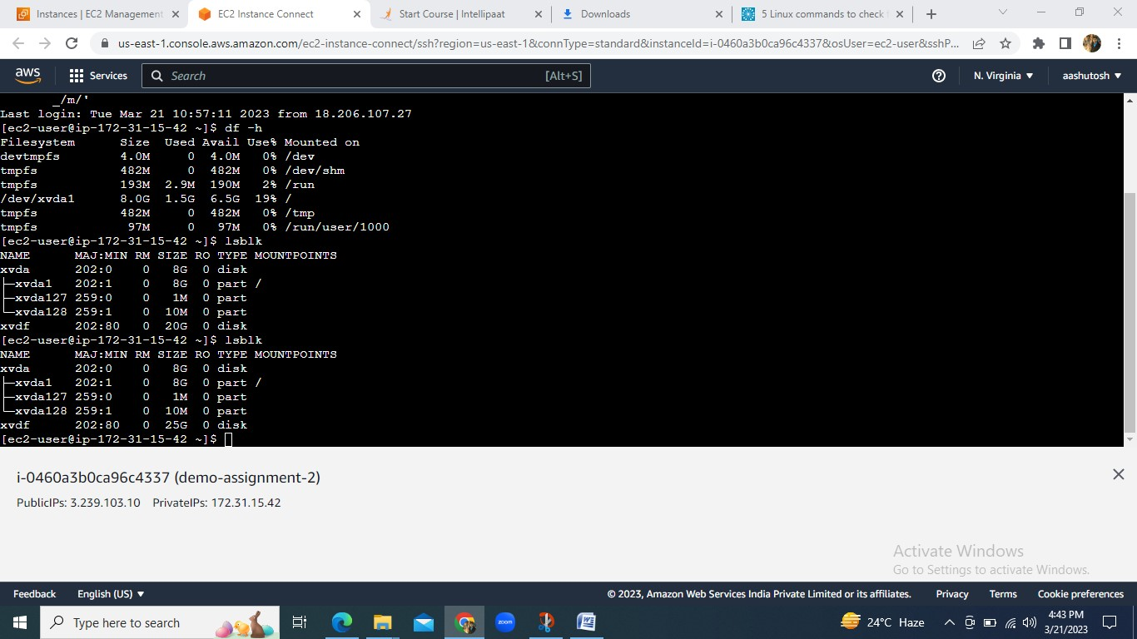

1. Create an EFS and connect it to 3 different EC2 instances. Make sure the all instances have different Operating System. For instance, Ubuntu, Red Hat Linux and Amazon Linux 2

